SIT 757

“Claytown”

VISUAL ASSET DEVELOPMENT

Unit title: Content Creation for Virtual Reality

Unit Chair: Alexander Baldwin

Author: Tong-Chang Wu (SID:213288591)

Date submitted: 1/9/2018

Content

Introduction 2

Visual Assets 2

Car 2

Building 5

Streetlight 9

Character 11

References 12

# Introduction

The content of this document is going to demonstrate the development process of the visual assets been created in this portfolio.

Since all the visual assets would be seen from top down which that I will be using normal maps to make all the assets detail to be seen more clearly.

# Visual Assets

## Car

Ideally, this project is designed for younger kids which my asset should not be realistic. That should be cute and interesting. Therefore, the car has produced below.

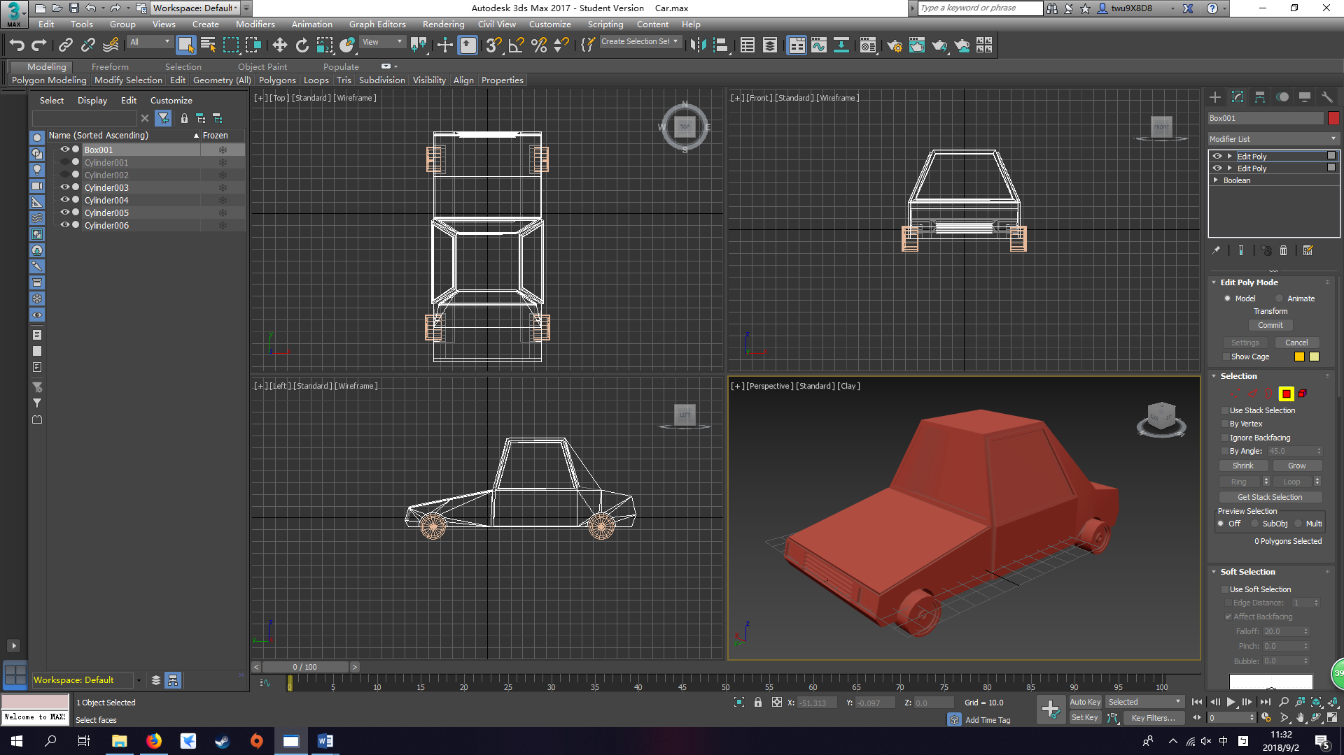I started creating the car body first by using what I learned from the class, as we can see the picture below, I was trying to make a tyre whole from the car body. But I didn’t know how to do it because the 3d Max in my house is 2017 not 2016. Therefore, I asked my friend also in the video Boolean Subtract 3ds Max 2017 by GameDesignDude (2017) about how to use Boolean function to achieve my purpose.

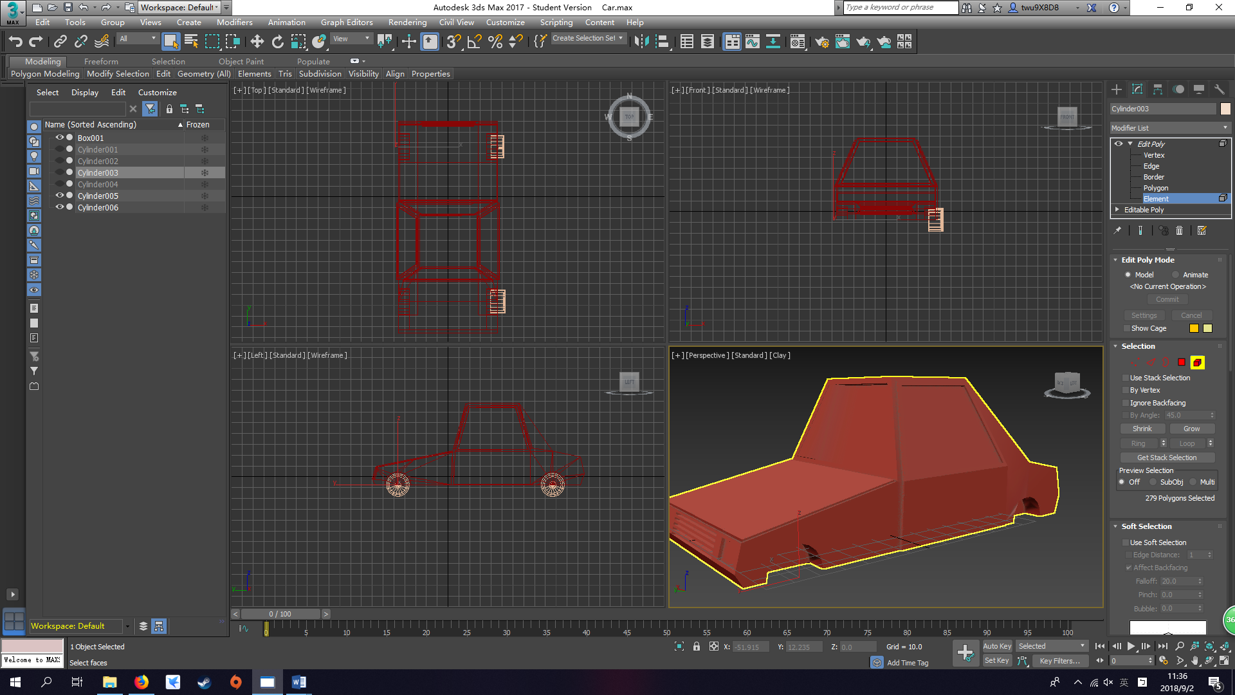

While I am creating for the car body, those very detail part like the inlet of the car and those head light at the front took me a lot of time to create it. I have to make sure the vertexes are welded without any cap.

After finishing the car body, I start creating tyre for the car. Some details work has been done for the tyre. So, I could use Boolean function to create a tyre hole on the car body by the tyre I created.

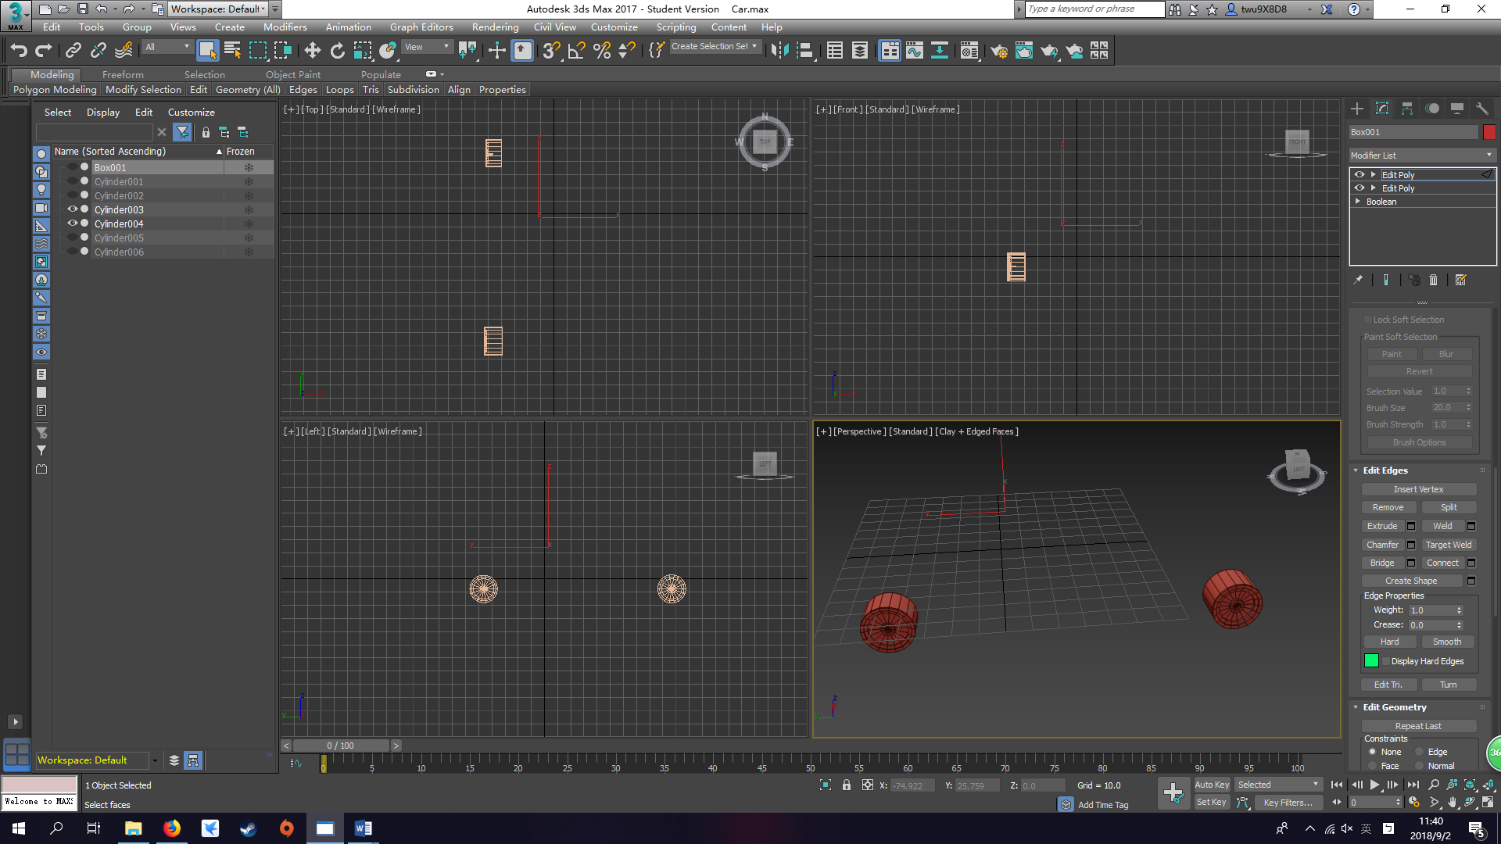

After I applied my tyre on to the car body, I connect the line at the middle of the car and chose the vertex for half the car and delete. Therefore, I could use symmetry function to create the other side with the tyre hole and tyre that been created on one side.

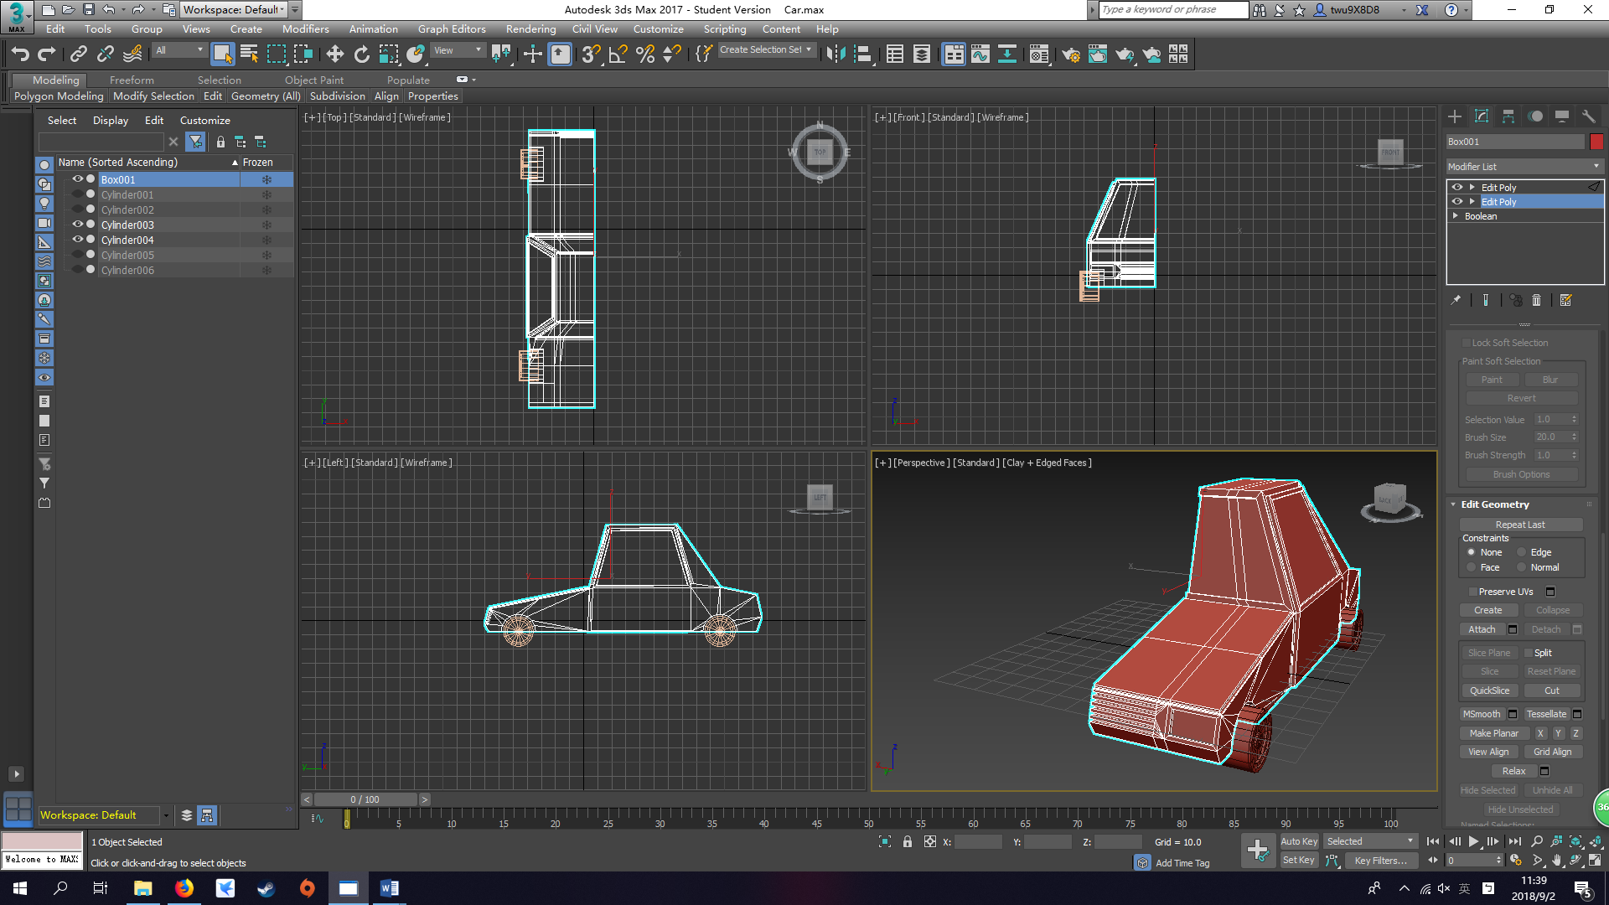

I just update my car UVW and texture on it. So here is the update below:

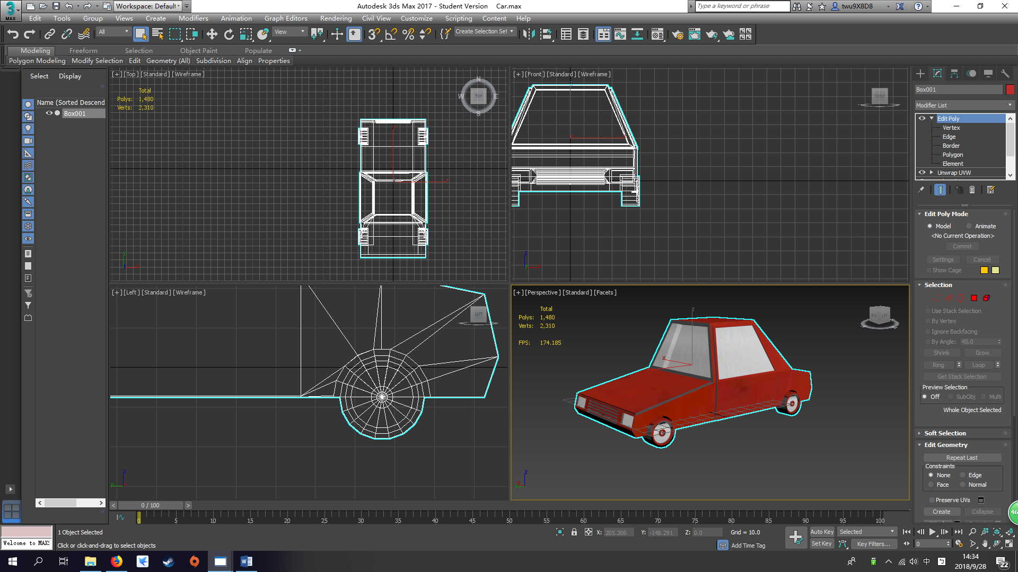

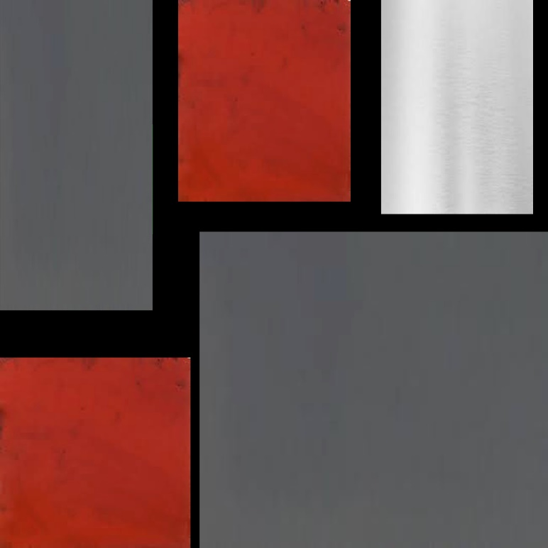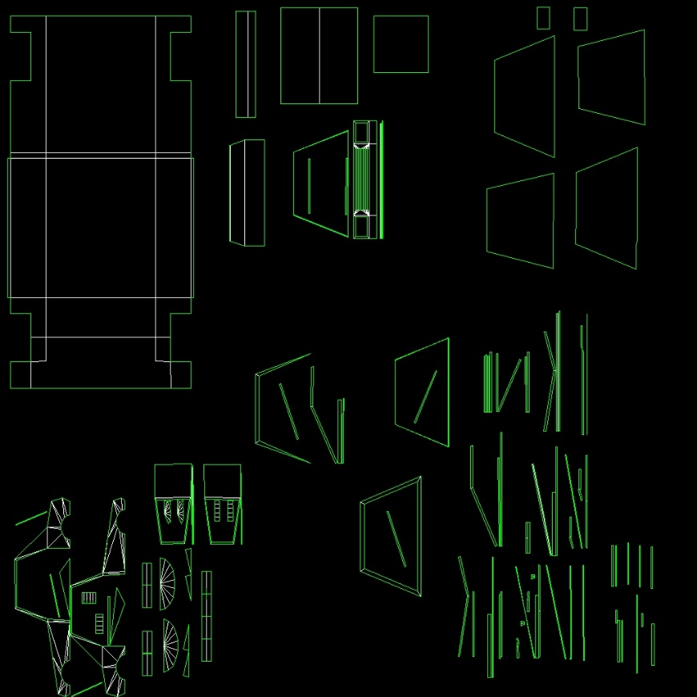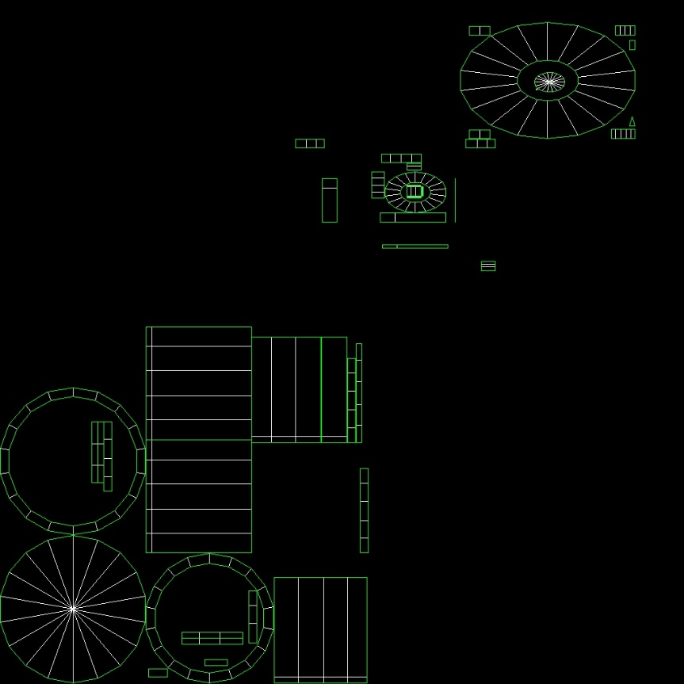The picture below are the UWV and texture (before and after):

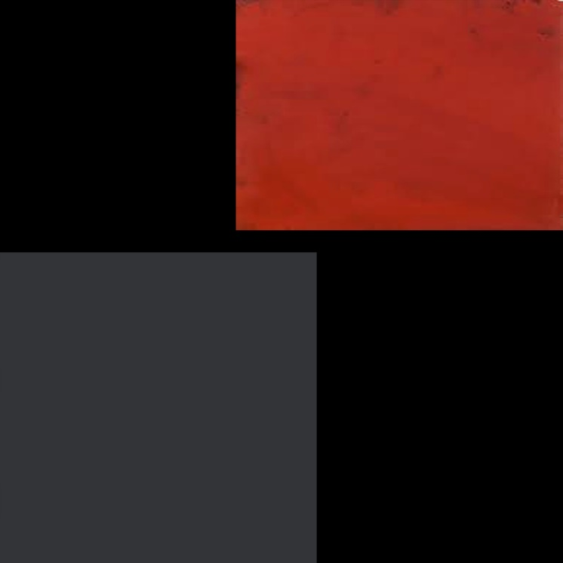

## Building

The building below is my first building

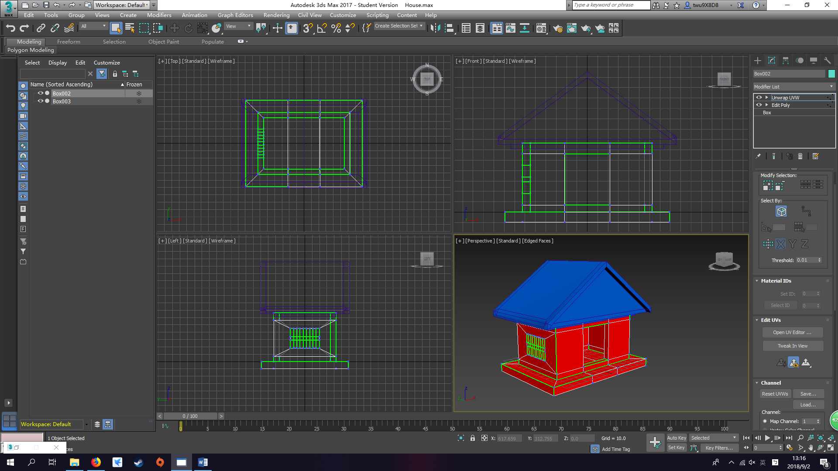

I started with the body of the building created an old fashion window and door

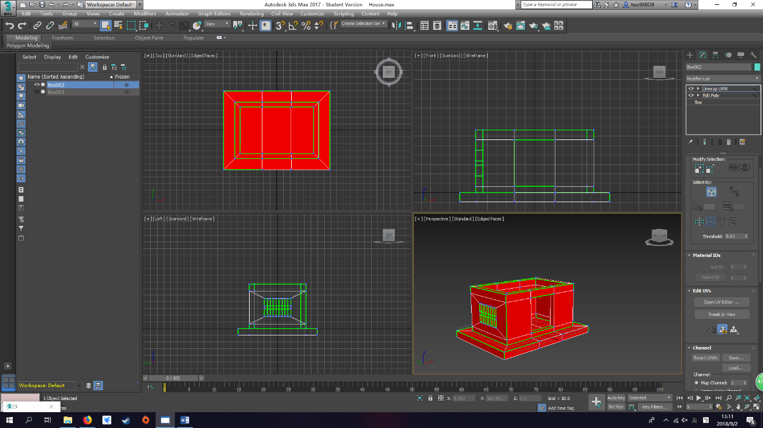

Then I created a roof for the building below

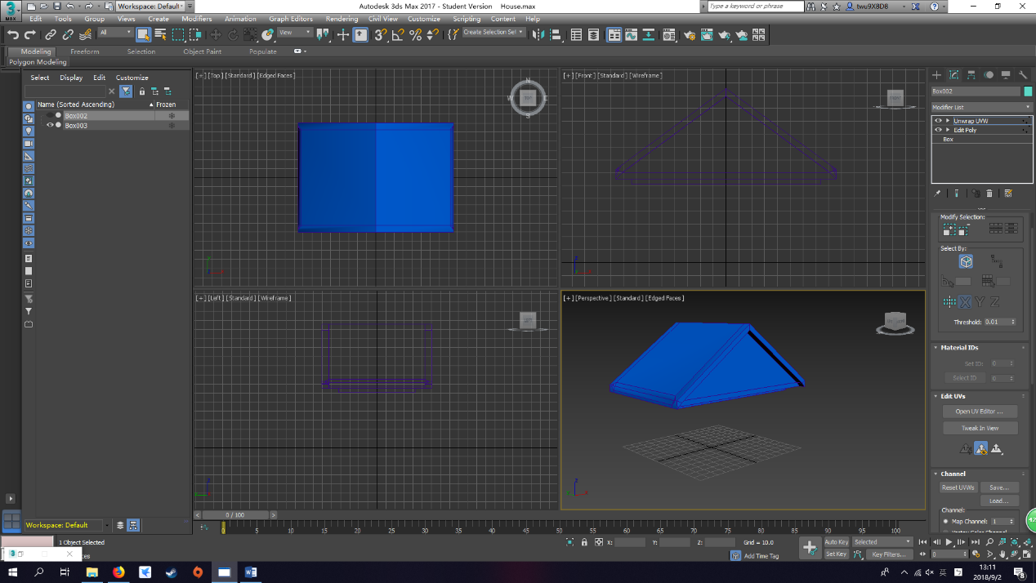

After finished the basic structure of the building, I started doing UVW function to make building body and roof connected side to side. Like below

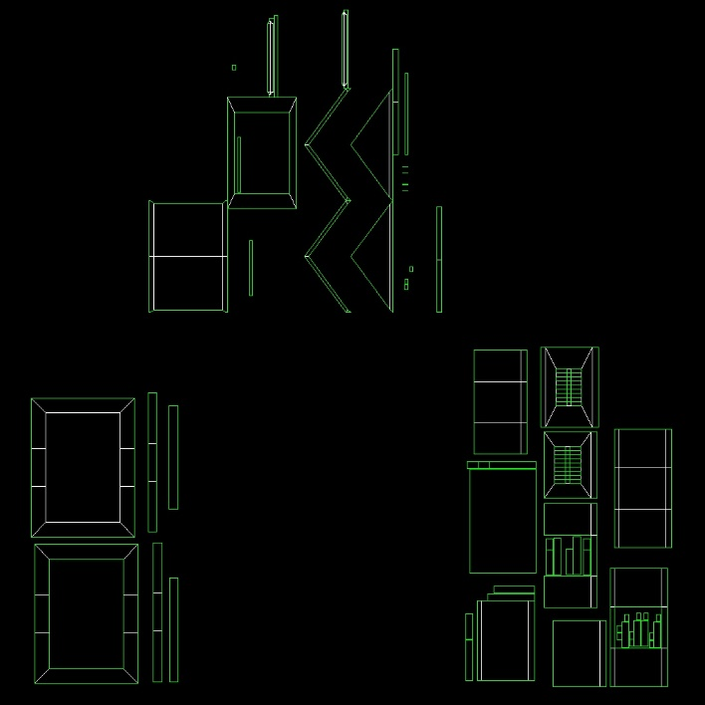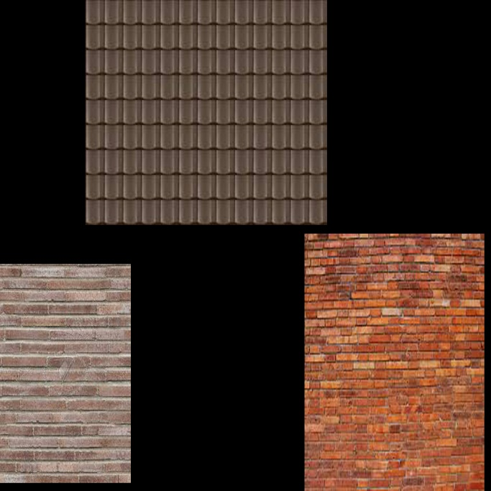

When I was creating the roof and the body, I found out that I didn’t cut some of the polygon into 3 or 4 sides. Therefore, when I use UVW function to spread the UV the way I wanted. So, it took me more to deal with each side and polygons. Eventually, I found a video 3DS MAX UV Mapping / Unwrapping Tutorial super fast & easy by JBGameStudios(2015) that talks about how to use UVW. Therefore, I got the output below. The 3 materials followed is the 3 materials I used for the roof and the house body.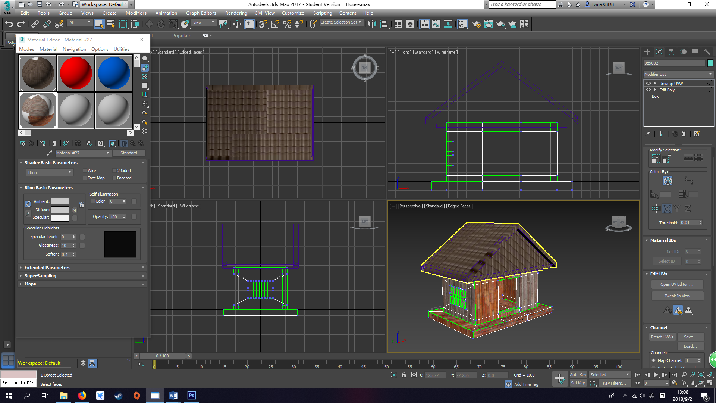 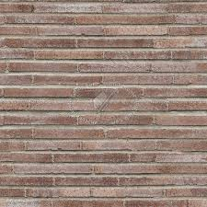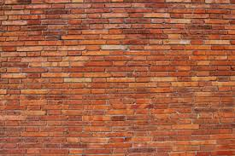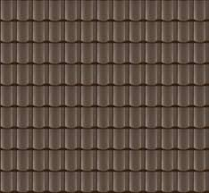

In the first folio, we can see the UVW and textures are a mess. So, I recreated a UWV map for house. As we can see the picture on below which is my final version of the house. The picture below is after I attach the head and body together and do a UVWMap with the texture. 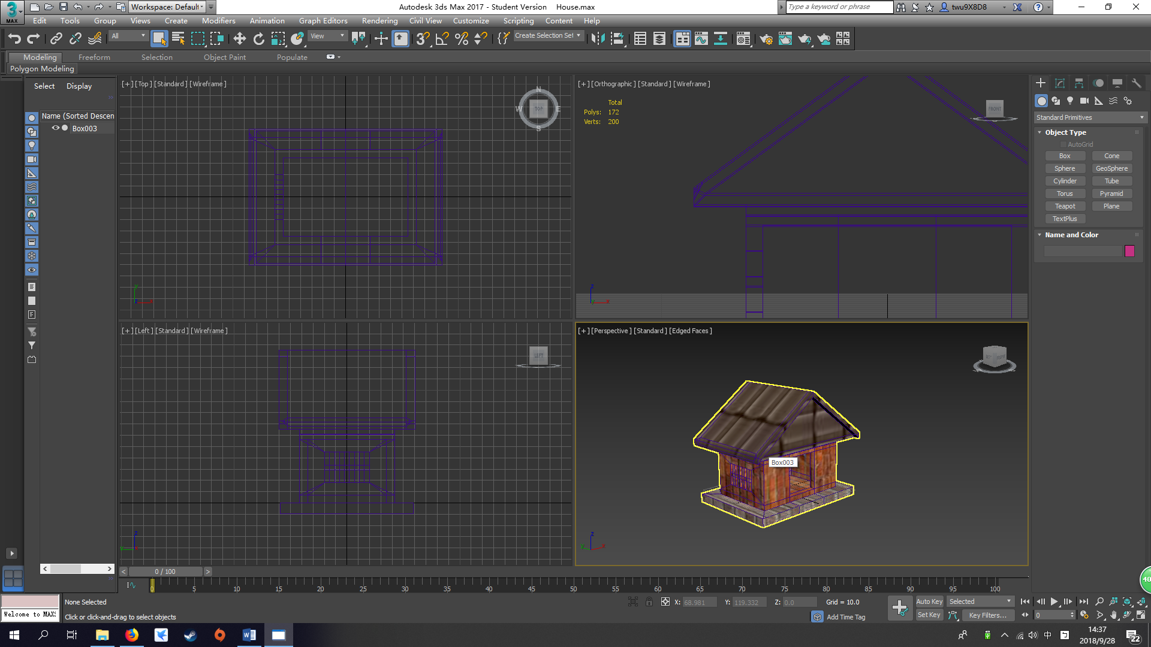

## Streetlight

The picture below is my streetlight:

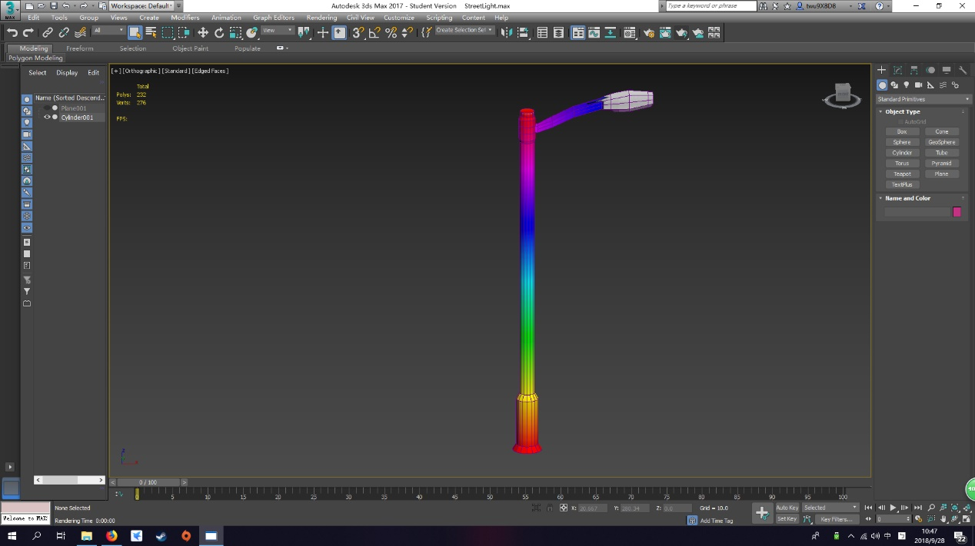

I started created a cylinder for the bottom of the object, and drag it up with some adjusting. Then, while I am creating the light part. I’ve encounter some problem which is that how to get a cylinder into a 6 sided object. Therefore, I have asked my friend about it. And he taught me connect 4 side together and again. Then, use the adjusting tool to adjust it to closely to the circle.

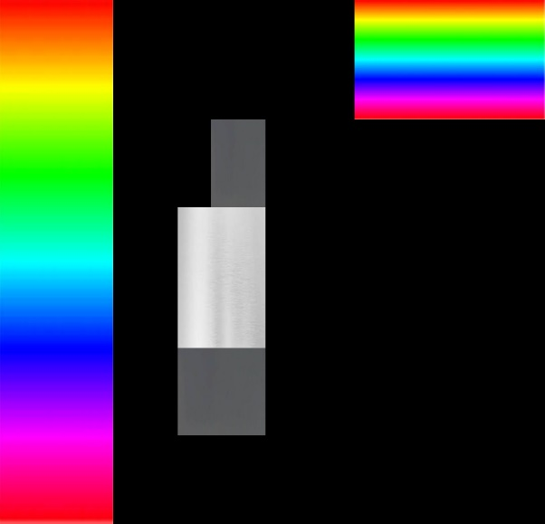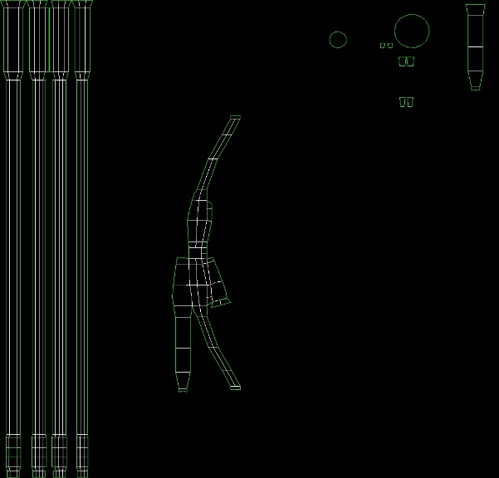The pictures below are the UVW for the streelight, before and after I applied the color on it.

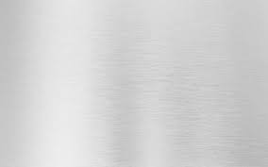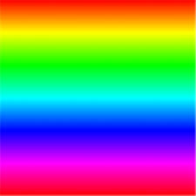The texture below are the materials texture that I used for streetlight.

The picture below is the final scene for creating streetlight.

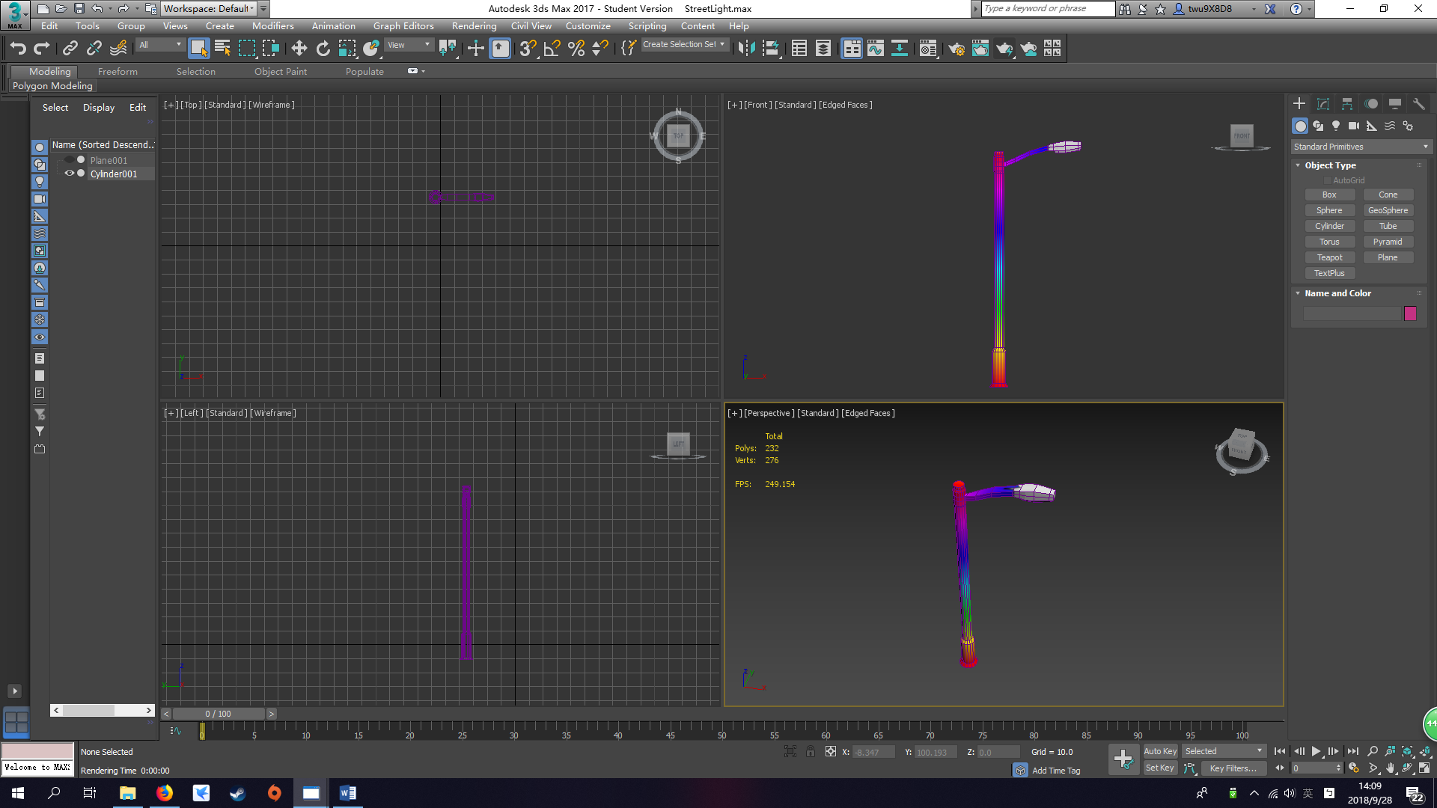

## Character

The pictures below is my NPC character:

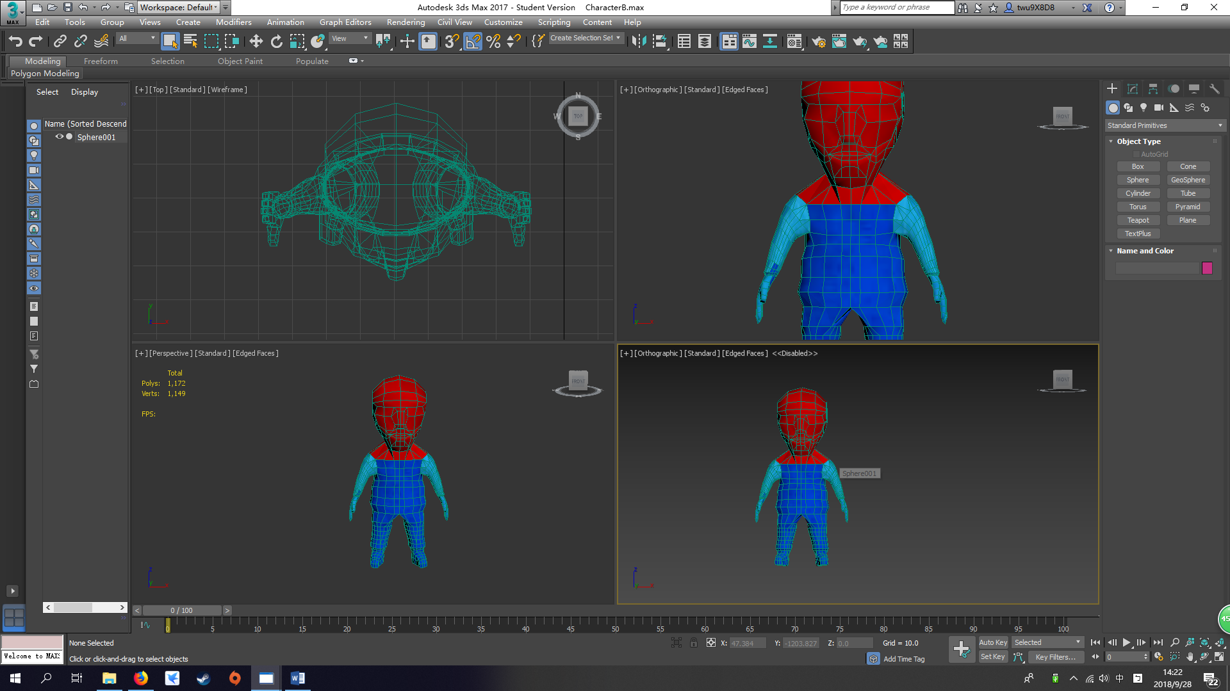

For the character, I started creating from the body then arm, foot, hand, shoes then head. While I am creating arm and foot. I’ve encounter some of the vertext couldn’t be weld. So I use edge faces mode and half transparency mode to find the problem. The problem was for each object like arm and foot their polygon that should be remove before attach. Therefore, I can weld those vertex together. Mostly, using symmertry to just doing half side of the character, so the computer will finish the other side for you.

The hardest part is creating the head, I started with a sphere, and using cut tool to cut the contour out. But is very hard to do it which took me 10 hours in total to cut all these contour out.

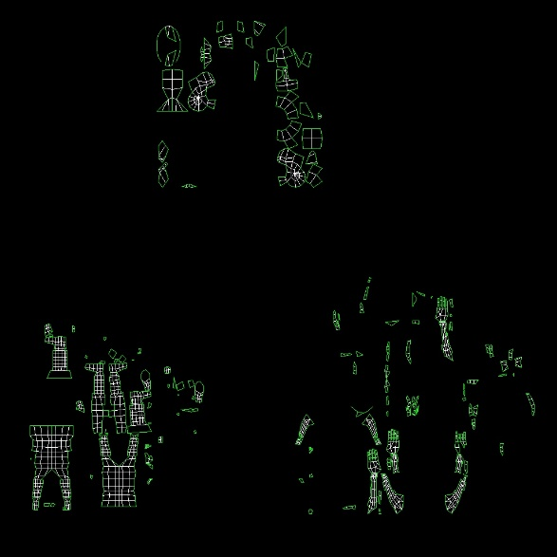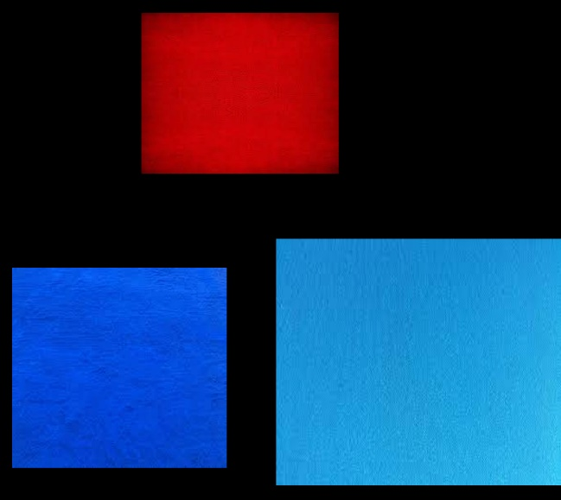The pictures below are the UVW for the streelight, before and after I applied the color on it.

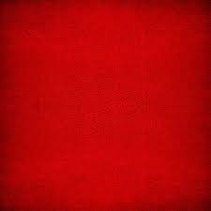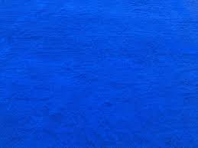The texture below are the materials texture that I used for Character.

# References

GameDesignDude, 2017, Boolean Subtract 3ds Max 2017, video recording, YouTube, viewed 1 Sep 2018,   
<<https://www.youtube.com/watch?v=fzfEgFCtyJE>>.

JBGameStudios, 2015, 3DS MAX UV Mapping / Unwrapping Tutorial super fast & easy, video recording, YouTube, viewed 1 Sep 2018,

<https://www.youtube.com/watch?v=XtHYHXogotw>